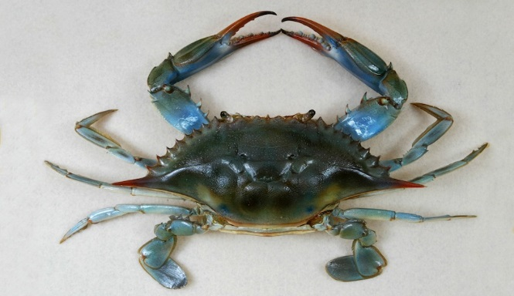
|…....I.......1……..I……..2…….I……..3……..I………4……..I……..5……..I……..6
The Blue Crab (Callinectes sapidus) is one of the Delaware Bay’s most important commercial and recreational species.
Delicious and easy to prepare, they can be caught from shore in many areas using simple traps or even hand lines.

Crabbing on the Delaware Bayshore:

If you want to enjoy a fun, family-friendly day on the Delaware Bayshore, and catch your dinner plan a crabbing trip! Crabbing is great way to spend time outdoors with the family; it is exciting, easy to learn how to do, and very inexpensive.

Cumberland County’s Bayshore region has many great places to catch crabs. No license is required, and the equipment and bait are inexpensive! Below, you will find a list of places to crab, stores where you can buy bait and equipment, or even rent a boat, and an over view of what to expect on your crabbing excursion.
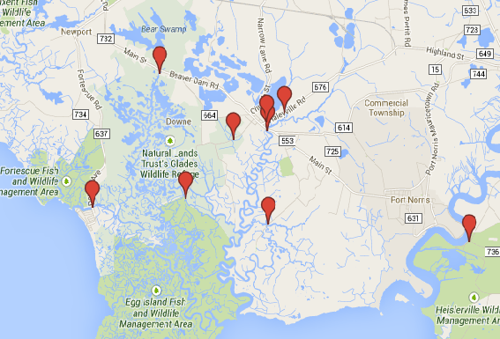
Be sure to bring:
Be sure to read up on all state regulations for crabbing and fishing!
http://www.state.nj.us/dep/fgw/njregs.htm
Rules for Recreational Crabbing:
Size Limits:
Peel or shedder (crabs in process of molting): 3 inches point to point.
Soft-shelled: 3 ½ inches point to point.
Hard-shelled: 4 ½ inches point to point.
Be sure to measure crabs from each point on the top shell.
Possession limit:
1 bushel basket for recreational crabbers.
Purchase bait, traps, or rent a boat!
Beaver Dam Boat Rentals, 514 Old Beaver Dam Rd, Newport, NJ 08345,
(856) 447-3633
Dividng Creek Boat Rentals, 988 Main St, Dividing Creek, NJ 08315
(856) 785-2828
Haase’s Marina, 114 Matts Landing Road, Heislerville, NJ 08324
(856) 785-7001

- Bug Spray
- Sunscreen
- Net
- Cooler or bushel basket

